**IDOC to File Scenario**

**Pre- requisite to start this development-**

**Enterprise Service Repository** - Software Components defined for Sender and Receiver System.

**Integration Directory** – Business System for ECC receiver needs to be defined.

**Business Logic behind this development**

Sender ECC system will trigger an IDOC to PI.

PI will perform the basic transformation/mapping.

The result of mapping needs to be send to the Receiver File placed in the folder.

**Design**

**Access to the Process Integration Tools:**

Link provided

<http://in-mum-solman:50000/dir/start/index.jsp>



**2. Access Enterprise Service Repository(ESR):**

Click on the link Enterprise Service Builder under Enterprise Service Repository. The following

Screen appears –



Login to PI using your user id and password.

**3. Import the software component define in SLD :**

**FYI: If Software Component is already imported please ignore this step.**

Import the following software component defined for the scenario into ESR

CAPGEMINI_TRAINER_MASTER, 1.0 of capgemini

Click on new under object and select SWCV under Work Areas.



Click on Display and select the required sender and receiver business system to be imported into ESR for further development

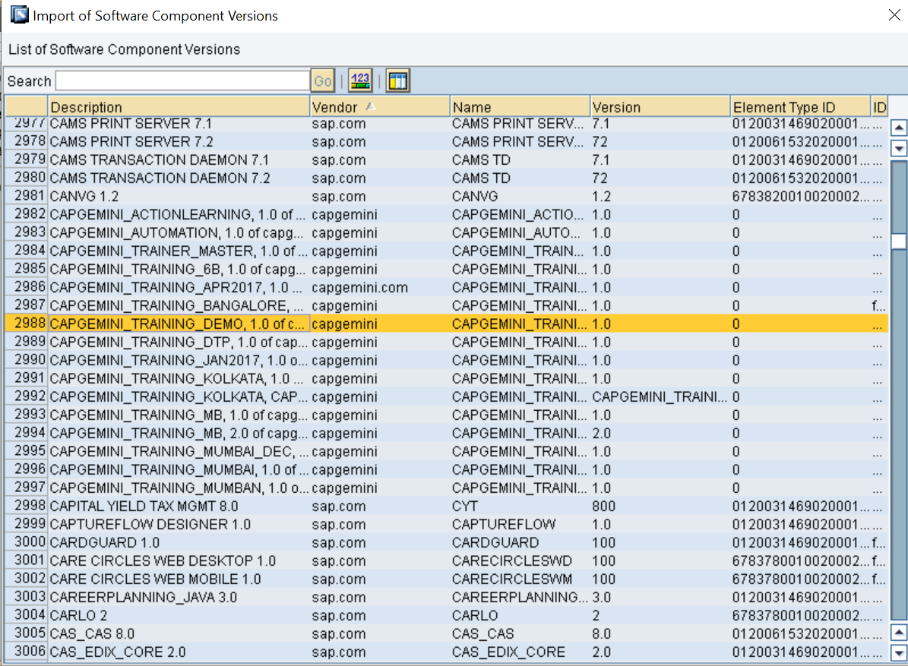

**4. Define Namespace**

You Define a Namespace for you SWCV that uniquely identifies all the objects you create in Repository.

Right click software component version and select Namespace from the context.

Create the following namespace

https://Capgemini.com/idoctofile_<<**last three digit of employee ID>>**

After creating and saving it appears like –

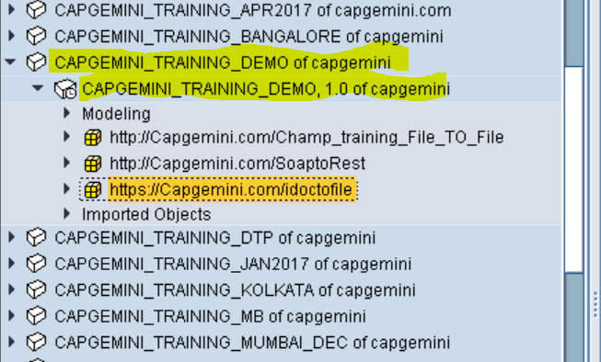

**5. Import IDoc**

**FYI: If IDOC is already imported, kindly ignore this step else follow the instructions listed below.**

**Note :** For Scenarios involving Idoc on sender/receiver , no need to define Data Type, Message

type and service Interface. Just need to import the IDoc for ECC server and use it in place of

message type and service interface.

Import the required IDoc into ESR under the software component defined for ECC system as below.

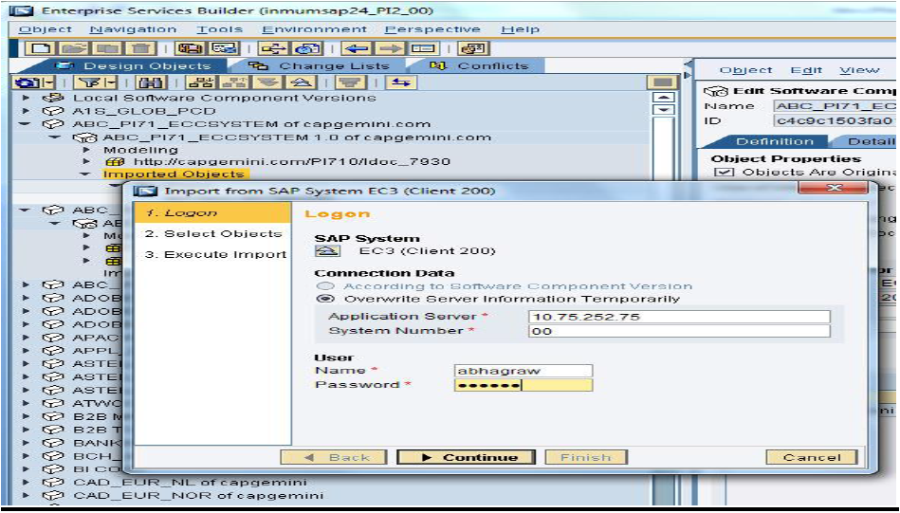

Select the **correct** Idoc required matmas or orders or invoice…etc and continue as under –

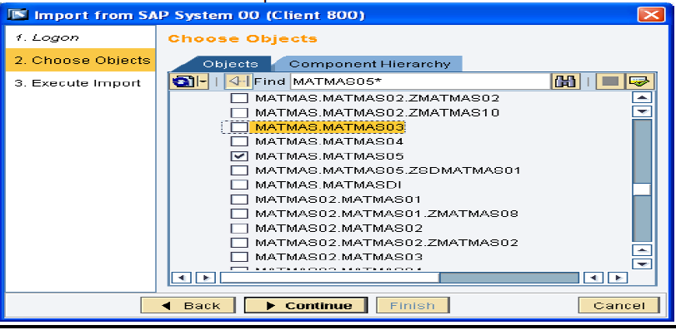

Once the Idoc is successfully imported, activate the same and it appear as below in ESR-



**6. Define Data Type**

Date type (DT_File_receiver_<Name/EmpNo> for receiver System.

Create data types with required structure and type of elements as shown below.

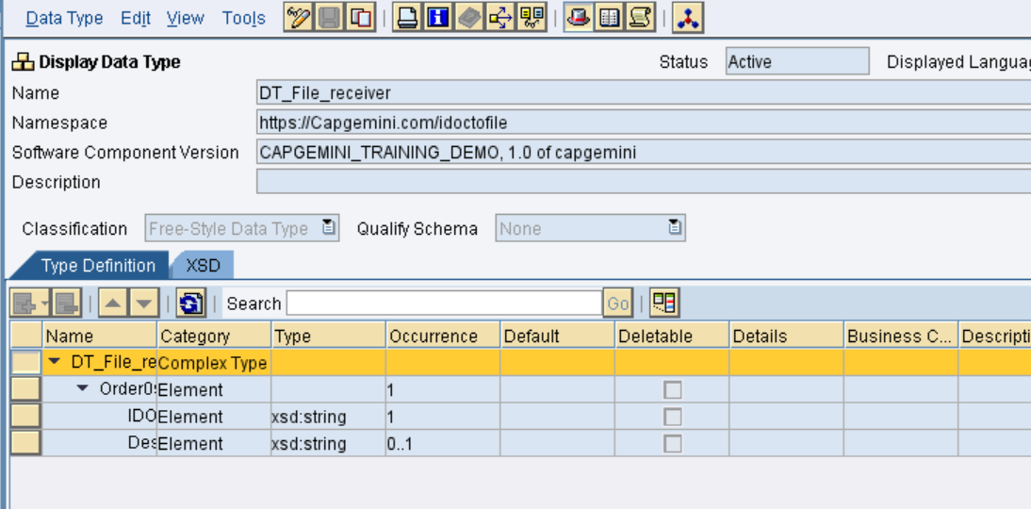

**7. Define Message Type**

Message type (MT_File_receiver_<Name/EmpNo> for receiver System

Select the Data type (created in the previous step)for the message type. The Namespace automatically gets populated. This is the message type for receiver system. Save after completing.

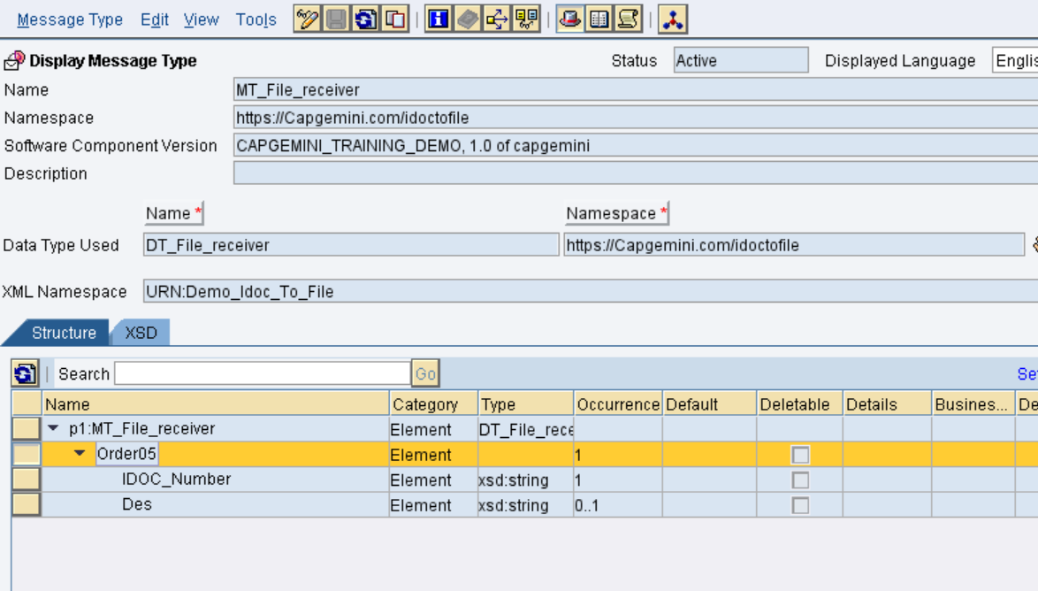

**8. Create Service Interfaces**

Service Interface (SI_File_in_< Name/EmpNo> ) for receiver System.

This is the service interface for the receiver system. Save after completing

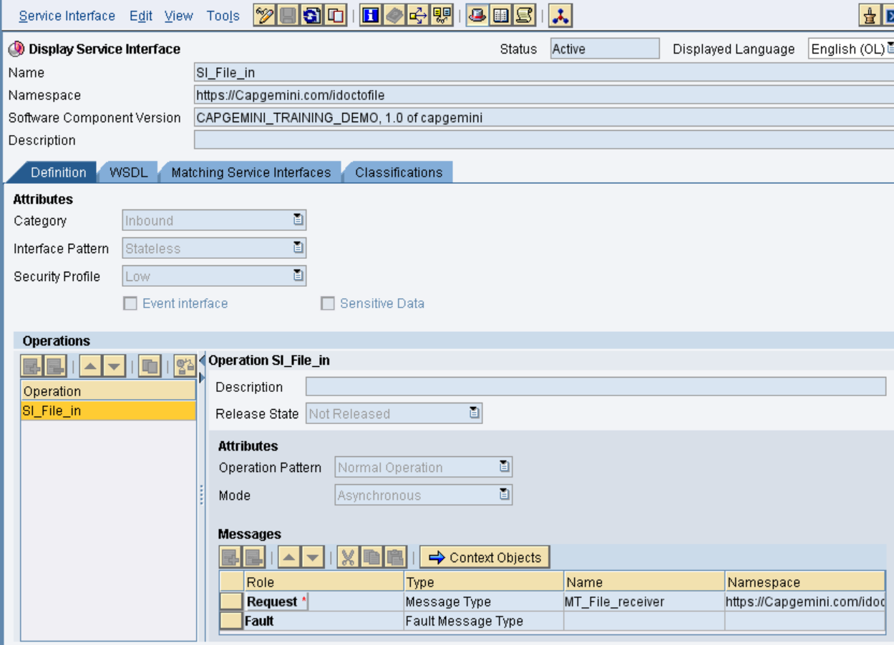

In the above snap in MODE operation we having 2 Types:

Asynchronous- One way message flow (Sender to Receiver)

Synchronous- two way message flow (Request and Response)

This is Asynchronous flow, we are using Quality of service as EO(Exactly once) or EOIO(Exactly once in order) depends upon flow.

**9. Create the Message Mapping**

Create a new Message mapping MM_Idoc_File_<Name/EmpNo>

The mapping in this scenario is one-to-one. The names of the source field and target fields are identical. To perform a mapping, drag the source fields and drop on the target field. The mapping would be displayed in the graphical display

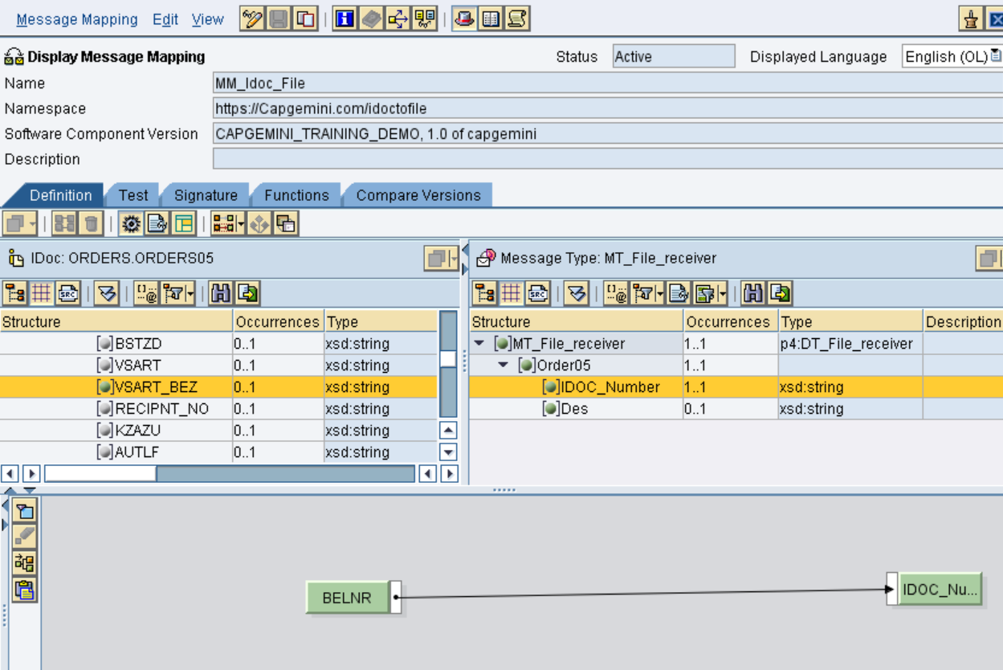

You can test you mapping by going to test Tab. You can select either of the two buttons from

the tool bar to test your scenario.

1. Load XM Instance load an XML file that contains your test data.

2. Generate Instance By specifying the value manually.

Now you can test the scenario by clicking the Execute Mapping.

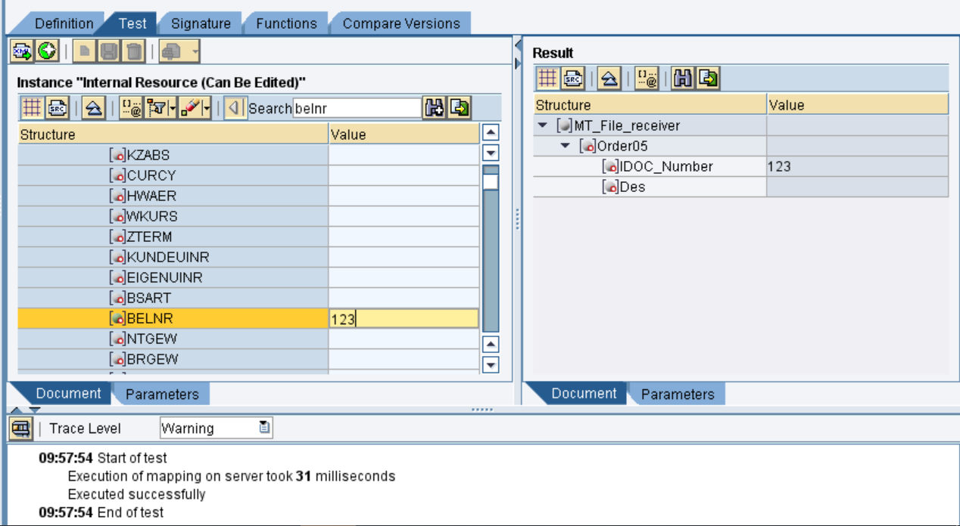

**10. Create the Operation Mapping:**

In OM_Idoc_File, select source interface “orders” and Target interface “SI_File_in” as shown below.

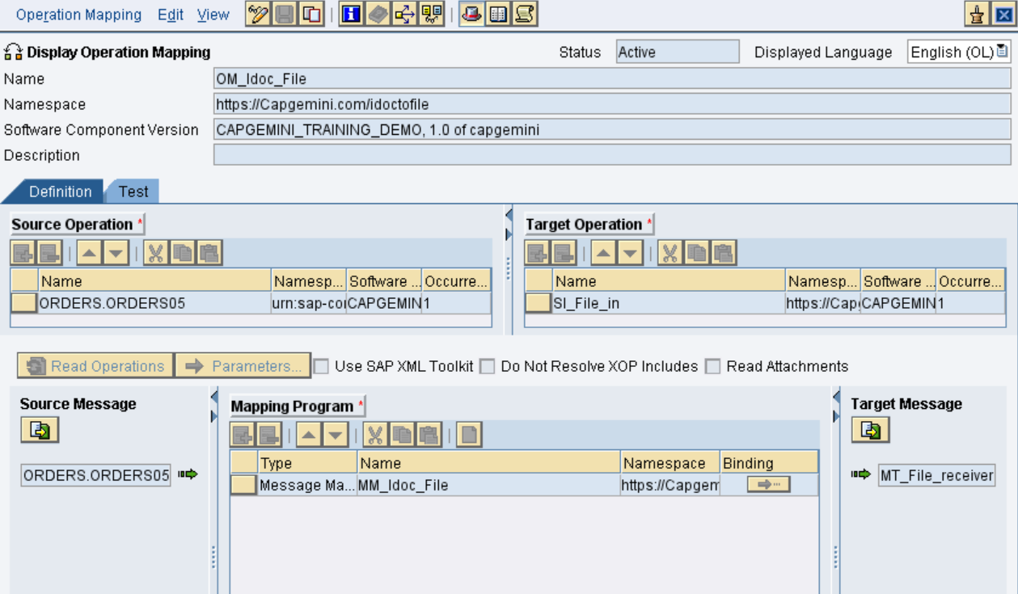

**Configuration:**

**Access to the Process Integration Tools:**

Link provided.

<http://in-mum-solman:50000/dir/start/index.jsp>

**Access Integration Directory:**

Click on the link Integration Builder under Integration Directory. The following screen appears as below



**Create a new scenario:**

Create a new CS in Integration directory with **CS_IdoctoFile** as shown below with with your ID as description.

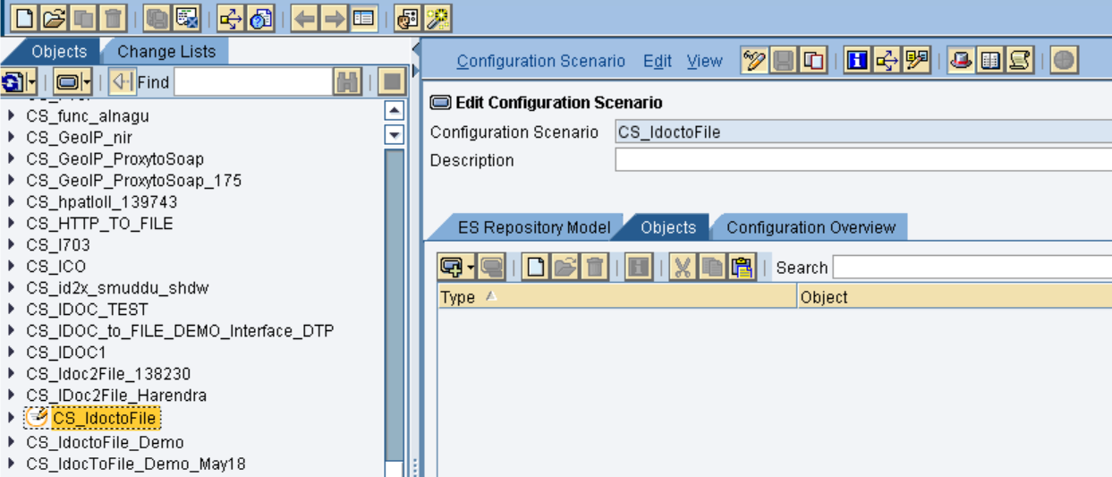

Create a BS for trigerring Idoc and BC to receive the file through PO. For now we are using the existing ones.

**Sender BS:**

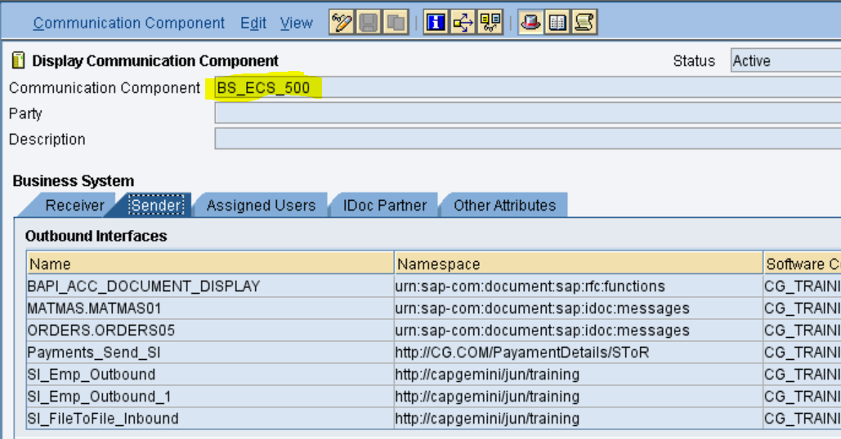

**Receiver BC:**

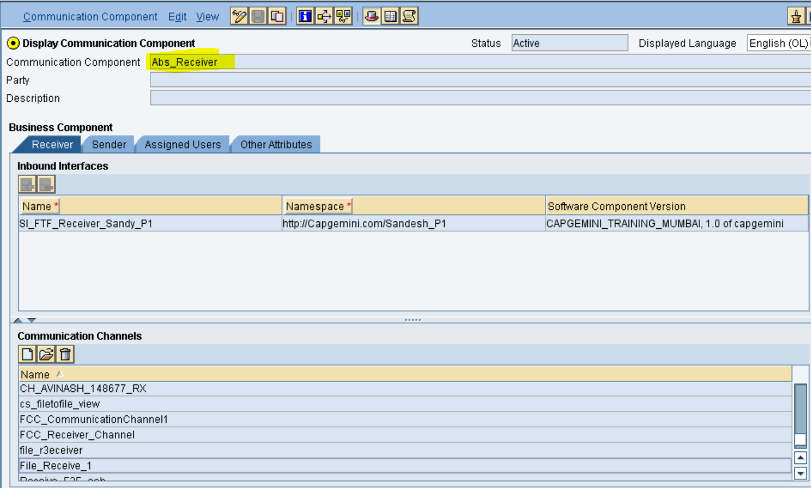

Create a communication channels for both sender and Receiver. For IDOC sender we will use common idoc sender channel.

**IDOC Sender:**

Note: Pre-requisite configurations in PO for outbound IDOC is:

--Create application resource in NWA, in that mention program ID (inboundRA ) pointing towards ECC.

--Create TCP/IP destination in SM59 in ECC, mention same program ID there.

Here we are reusing the IDOC sender channel as connection is already done

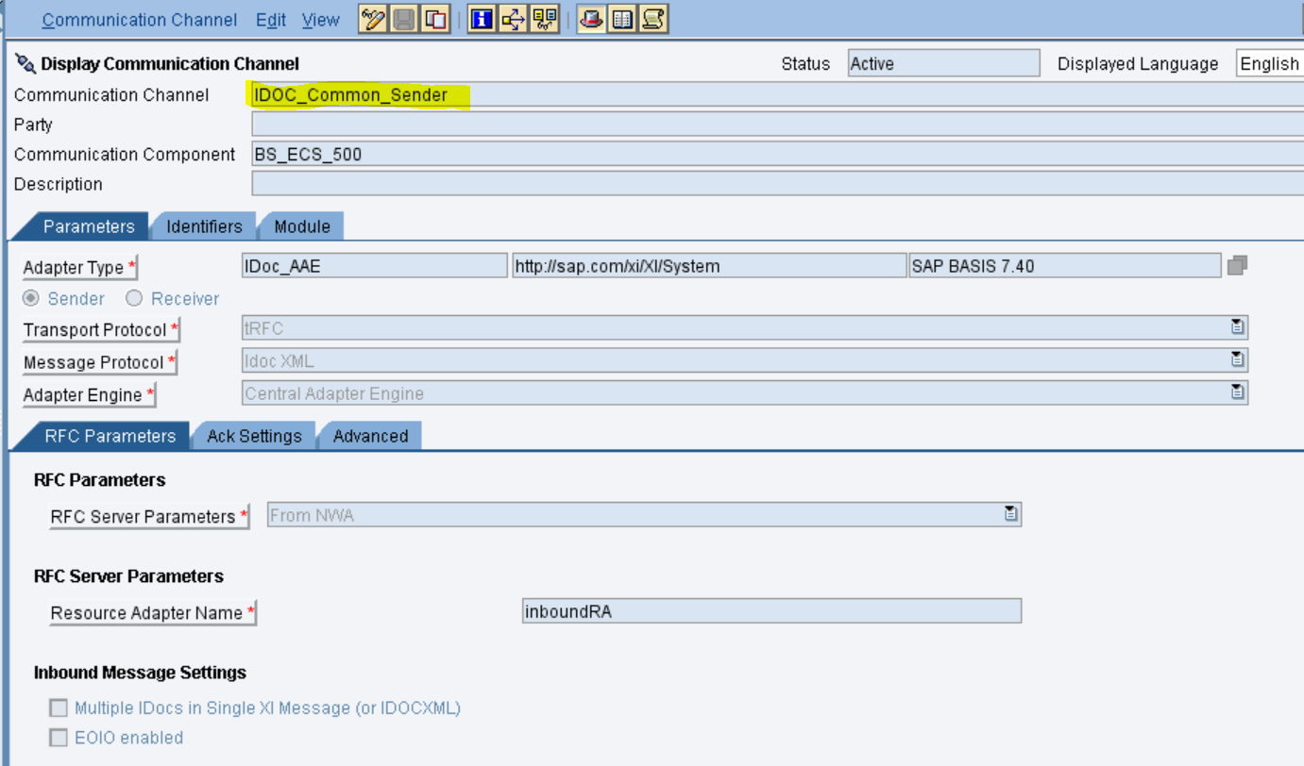

**File Receiver:**

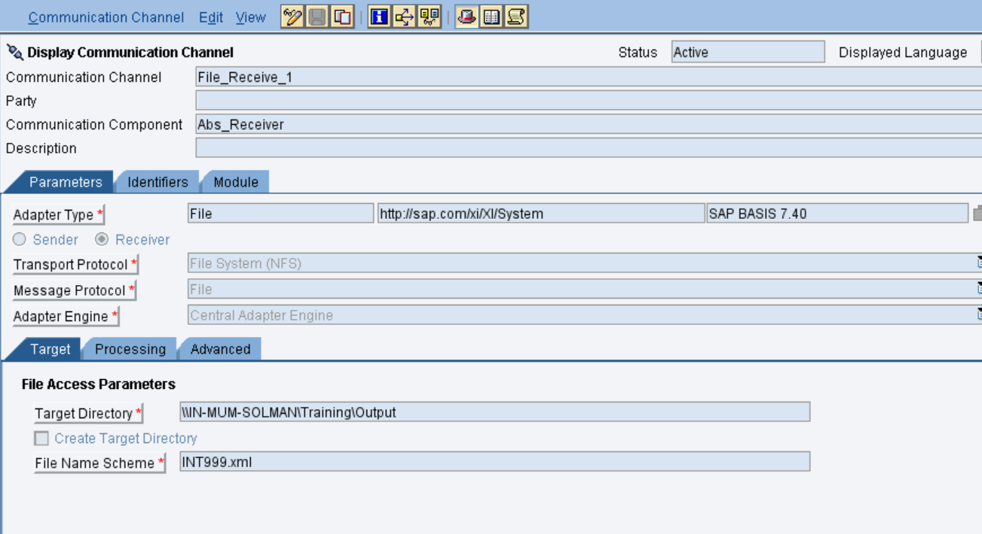

**ICO: Integrated Scenario**

CreateICO as below

